On the Moon

An astronaut is walking on the Moon

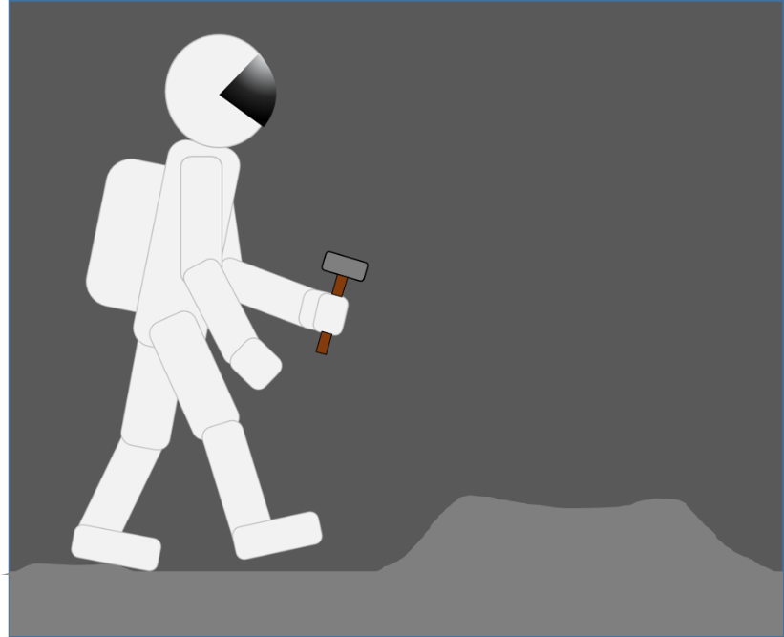

What do you think it is like on the Moon?
Which of these statements do you think are right?
For each statement, tick (✓) one column to show what you think.
 |  | I am sure this is right | I think this is right | I think this is wrong | I am sure this is wrong
A | There is no gravity because there is no air
B | Gravity is weaker than on Earth  so she can jump up and down more easily
C | Gravity is stronger than on the Earth
D | If the astronaut drops the hammer it will float next to her

Physics > Big idea PES: Earth in space > Topic PES1: Solar System and beyond > Key concept PES1.1: Gravity
Diagnostic question
On the Moon

Overview
Learning focus: | Gravity is the force that holds the Solar System together
Observable learning outcome: | - Describe how gravity increases with the mass of a planet (or other astronomical body)
Question type: | Diagnostic, confidence grid
Key words: | Gravity

What does the research say?
A widespread view of gravity amongst 11-to-17-year-olds, is that it is a ‘holding’ force rather than a pulling force. This thinking is bound up with the idea that gravity is linked to the atmosphere, and with air pressing down to stop things floating away (Stead and Osborne, 1980; Driver et al., 1994). This can lead to the misunderstanding that there must be air for there to be gravity. This has implications for thinking about gravity acting in space, on other planets and on the Moon.
In a study Stead and Osborne (1980) found that it is common for eleven-year-olds to think that gravity only relates to the Earth. At age thirteen (n=258) 44% do not think there is gravity on the Moon, and they commonly think that not all planets have gravity. 81% of 13-year-olds and 75% of 14-year-olds in the study do not think there is gravity in space .
This question investigates students’ thinking about the Moon specifically and gives the opportunity for starting to discuss the connection between gravitational attraction and mass.
Ways to use this question
Students should complete the confidence grid individually. This could be a pencil and paper exercise, or you could use an electronic ‘voting system’ or mini white boards and the PowerPoint presentation.
If there is a range of answers, you may choose to respond through structured class discussion. Ask one student to explain why they gave the answer they did; ask another student to explain why they agree with them; ask another to explain why they disagree, and so on. This sort of discussion gives students the opportunity to explore their thinking and for you to really understand their learning needs.
Differentiation
You may choose to read the questions to the class, so that everyone can focus on the science. In some situations it may be more appropriate for a teaching assistant to read for one or two students.

Expected answers
B: ‘gravity is weaker than on Earth so she can jump up and down more easily’ is the only correct statement
How to respond - what next?
Answer A clearly identifies students who think that gravity is dependent on air being present. Answer D reveals a more subtle misunderstanding and the idea that the hammer and astronaut can experience gravity differently. This answer indicates that the student may be using visual evidence from the picture to think about the astronaut, but is reverting to a misunderstanding of gravity to explain the hammer. They clearly do not understand that gravitational force is caused by the mass of the Moon (and the objects).
If students have misunderstandings about gravity on the Moon, it can help to show the picture of the Apollo 11 mission to the Moon (PowerPoint slide 3), which shows a variety of equipment and rocks clearly on the ground because of the force of gravity.
It can be helpful to discuss how the Moon attracts objects towards it because of its mass, and how the Earth has a stronger gravitational force than the Moon because of its larger mass. This gives students a brief insight into a scientific understanding of the cause of gravity that is expressed in Newton’s universal law of gravitation.*
A suitable response activity could be to give students the opportunity to apply their understanding to a new situation, for example by using the following BEST ‘response activity’:
- Response activity: Different weight?
* Newton’s universal law of gravitation states that all objects with a mass attract all other objects with a mass, and that the strength of the force is proportional to the product of the masses of the two objects. This is a challenging idea that is often taught to physics students aged 16-18.
Acknowledgments
Developed by Peter Fairhurst (UYSEG), based on EPSE question F05-041.
Images: Peter Fairhurst (UYSEG), photograph from NASA's Scientific Visualization Studio
References
Driver, R., et al. (1994). Making Sense of Secondary Science: Research into Children's Ideas, London, UK: Routledge.
Stead, K. and Osborne, R. (1980). Gravity. Hamilton, New Zealand: LISP Working Paper 20, Science Education Research Unit, University of Waikato.

